COMMUNITY EMPOWERMENT (SCOTLAND) ACT 2015

ASSET TRANSFER REQUEST FORM

The Falkirk Braes Grange Centre
Community Asset Transfer – Grange Community Centre, Brightons, FK2 0AA

IMPORTANT NOTES:
You do not need to use this form to make an asset transfer request, but using a form will help you to make sure you include all the required information.
You should read the asset transfer guidance provided by the Scottish Government before making a request.
You are strongly advised to contact the authority and discuss your proposals with us before making an asset transfer request.
When completed, this form must be sent to Falkirk Council which owns or leases the land your request relates to.

This is an asset transfer request made under Part 5 of the Community Empowerment (Scotland) Act 2015.
- Information about the community transfer body (CTB) making the request
  - Name of the CTB making the asset transfer request
The Falkirk Braes Grange Centre
  - CTB address. This should be the registered address, if you have one.
Postal address:
Grange Community Centre, Redding Road, Brightons
Postcode: FK2 0AA
  - Contact details. Please provide the name and contact address to which correspondence in relation to this asset transfer request should be sent.
Contact name: [REDACTED]
Postal address: Grange Community Centre, Redding Road, Brightons
Postcode: FK2 0AA
Email: FalkirkBraesGrange@gmail.com
Telephone: [REDACTED]
 We agree that correspondence in relation to this asset transfer request may be sent by email to the email address given above. (Please tick to indicate agreement)
You can ask Falkirk Council to stop sending correspondence by email, or change the email address, by telling them at any time, as long as 5 working days’ notice is given.
  - Please mark an “X” in the relevant box to confirm the type of CTB and its official number, if it has one.
 | Company, and its company number is ………….
x | Scottish Charitable Incorporated Organisation (SCIO), and its charity number is ……………….. | SC053512
 | Community Benefit Society (BenCom), and its registered number is ………………………………
 | Unincorporated organisation (no number)

Please attach a copy of the CTB’s constitution, articles of association or registered rules.
  - Has the organisation been individually designated as a community transfer body by the Scottish Ministers?
No ☐
Yes ☐
Please give the title and date of the designation order:
n/a
  - Does the organisation fall within a class of bodies which has been designated as community transfer bodies by the Scottish Ministers?
No ☐
Yes ☐
If yes, what class of bodies does it fall within?
Community Controlled Body

- Information about the land and rights requested
  - Please identify the land to which this asset transfer request relates.
You should provide a street address or grid reference and any name by which the land or building is known. If you have identified the land on the relevant authority’s register of land, please enter the details listed there.
It may be helpful to provide one or more maps or drawings to show the boundaries of the land requested. If you are requesting part of a piece of land, you must attach a map and full description of the boundaries of the area to which your request relates. If you are requesting part of a building, please make clear what area you require. a drawing may be helpful.
Grange Community Education Centre, Redding Road Brightons FK2 0AA (yellow highlighted area)
987.347 GIA (sqm)
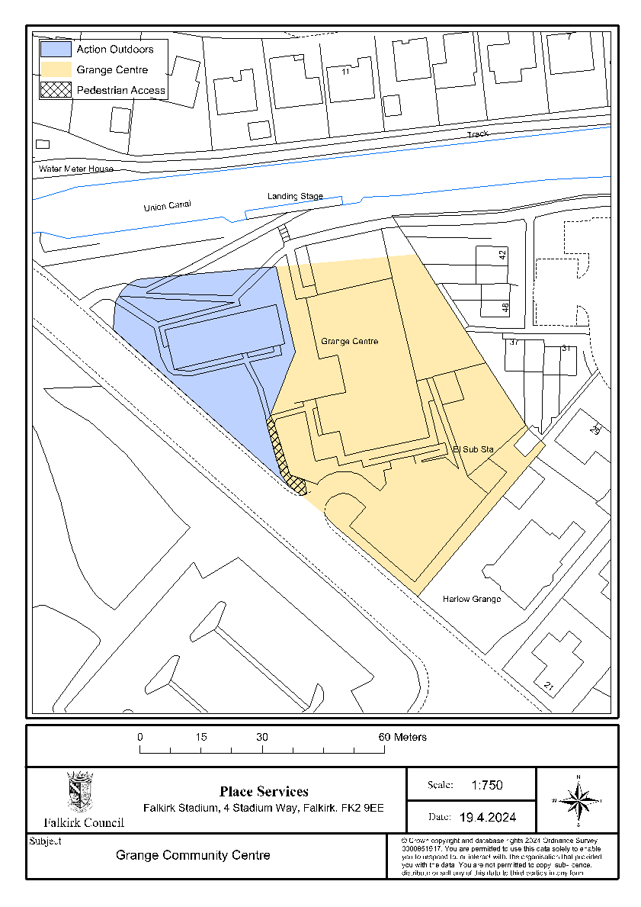
  - Please provide the UPRN (Unique Property Reference Number), if known.
Please see Falkirk Council’s register of land assets for UPRN
UPRN: 136040440

- Type of request, payment and conditions
  - Please tick what type of request is being made:

for ownership (under section 79(2)(a)) - go to section 3A

for lease (under section 79(2)(b)(i)) – go to section 3B

for other rights (section 79(2)(b)(ii)) - go to section 3C

3A – Request for ownership
What price are you prepared to pay for the land requested?:
Proposed price: £1.00
Please attach a note setting out any other terms and conditions you wish to apply to the ownership request.
1. Before taking over the property, the name of the building is changed to ‘The Falkirk Braes Grange Centre’ from ‘Grange Community Centre’ in the address to avoid confusion.

2. Both parties will cover their own legal expenses, when incurred.

3. Before taking over the property, we propose the carpark is changed to shared use between the two assets. We therefore request access rights, vehicle access and will form a joint maintenance agreement for upkeep.

4. Remove both containers from the grounds of the Grange and make good the land

- Remove the graffiti from the rear of the external Games Hall brick wall (facing canal) – looks like this has subsequently been painted over but still is not to an acceptable standard.

- Remove EV charging points and make good the land, including re-painting the car parking spaces

- Address remedial works in relation to the EICR

- Check compliance on lower-level Disabled Access toilet as this is up 5 steps from the Games Hall, therefore inaccessible. If proved to be non-compliant, remediate accordingly.

3B – request for lease
What is the length of lease you are requesting?

How much rent are you prepared to pay? Please make clear whether this is per year or per month.
Proposed rent: £ per year
Please set out any other terms and conditions you wish to be included in the lease, or to apply to the request in any other way.

3C – request for other rights
What are the rights you are requesting?

Do you propose to make any payment for these rights?
Yes ☐
No ☐
If yes, how much are you prepared to pay? Please make clear what period this would cover, for example per week, per month, per day?
Proposed payment: £ per
Please set out any other terms and conditions you wish to apply to the request.

Community Proposal
  - Please set out the reasons for making the request and how the land or building will be used.
This should explain the objectives of your project, why there is a need for it, any development or changes you plan to make to the land or building, and any activities that will take place there.
We are a community group looking to save the Grange Community Centre from closure. Since May, we have been marketing the centre as a Sports and Wellbeing facility as we believe our Games Hall to be our unique selling point over all other community centres in the local area. With the potential closure of Polmont Sports Centre in 2025, we may be the only games hall venue in the area. As well as being able to secure a commercial gym and a sports Massage Therapist to rent permanent/long-term space within the centre, we have also been able to increase our Games Hall usage to 40% capacity through local community engagement and engaging Social Media posts. Our committee team mostly consist of representatives from each the groups using the centre as well as members of the community therefore all have a vested interest in making the centre a success. We have a variety of sports groups and clubs using the centre now: Badminton, Basketball, Golf, Football, Table Tennis, Meta Fit, Yoga, Archery, Dance lessons and Rollerblading. We also have support and educational groups: Speakers Club and Women’s Support Group.
Our community engagement survey had a fantastic response of 325 unique respondents, all with support and encouragement of how to better the centre. We reviewed all requests and accommodated where possible to make the centre what it is today and will be in the future, for the community.
All the above is carried out in line with our objectives, as set out in our Business Plan, of improving the health and wellbeing of the local community, providing increased social benefits, empowering our community and families, reducing poverty in the area by providing essential services to help the wellbeing of the community and providing a space for children to alleviate child poverty in the area.
We realise that the car park is small in comparison to the current usage of the building therefore we have enlisted a Civil Engineering consultant to look at a possible car park expansion round the side of the centre. We also have an agreement with the SPS College across the road to share their carpark as an overflow as and when required.
Benefits of the proposal
  - Please set out the benefits that you consider will arise if the request is agreed to.
This section should explain how the project will benefit your community, and others. Please refer to the guidance on how the relevant authority will consider the benefits of a request.
The Falkirk Braes Community Centre provides essential services and spaces that might otherwise be inaccessible due to the financial constraints of our local community. We plan to offer employment opportunities once the asset transfer is complete, in the form of a cleaner, and a centre manager. The centre remaining open and in community ownership, will help to develop the skills and experience of our local community through volunteer places, to build upon an individual’s experience and skills capacity, thus supporting our community’s future employability.
Our centre hosts regular speaking confidence groups for further personal development, which can have a positive impact on an individual's job prospects and education prospects. Our users are better able to conduct themselves in interviews, within a work setting, and other social settings, meaning that they can make those meaningful and impactful relationships that can help them in their personal, professional, and educational life.
We provide multiple work experience placements to provide experience, permanent & casual employment opportunities. We support local child businesses, providing them with an affordable venue for their services.
We will have a progressive pricing structure, making it affordable to use our centre to allow access for all.
Unfortunately, due to the economic climate and the cost-of-living crisis, there has been a decline in the number of businesses, venues, and amenities in our community. The closing of a vital community building would be hugely damaging to the local area. We have plans to upgrade our space and our garden area, so that it can be enjoyed by our whole community. We plan to continue our community work to contribute to the local regeneration of the area. Our initiatives of hosting outdoor events, supporting local businesses, and advocating for community needs, means that we are actively engaging with our broader community: our community centre helps create a more vibrant, connected, and resilient local area.
We plan to regenerate the centre, so that it is a modernised, well-equipped and functional hub for our community.

By improving the overall health of the community, our group aims to help ease the pressure on public and social services, and on other facilities. Our LET helps to combat mental health issues in our local area. By engaging in regular social activities, our community can reduce stress, improve mood, and gain a sense of purpose. Physical activities at our centre, such as yoga classes, martial arts classes, and dance classes, help maintain physical health and mobility for all those who attend them. Together, these benefits contribute to a healthier, happier, and more connected community. When individuals have access to programmes that support their social, mental, and physical health, they are less likely to require intervention from public services. This proactive approach to community health not only benefits individuals, but also reduces the burden on public resources, allowing them to be allocated more effectively, to areas where they are needed the most.
Mental Health is improved due to increased social interaction, the reduction of social isolation, and more wealth is retained within the local community.
We know that 1 in 4 people experience some form of poor mental health in their lifetime, and that mental health is an umbrella term which encompasses not only mental health problems/illness and mental health wellbeing. Therefore, it should be highlighted that the Grange could help reduce this by creating some breathing space and balancing out the mental load that those in our community are facing. We plan on opening a wellbeing cafe, that will operate from our centre, allowing individuals to interact in a safe and neutral space.
By way of encouraging physical movement, offering multiple sports and fitness offerings for all ages and abilities. Additionally offering support groups for individuals to engage with, whether that be for mental health support, or physical health support, the Grange is always there as a venue for people to come together. There is a definite increase in people being more connected and coming together, people in the local area have an increased level of fitness, thus resulting in less interactions with the NHS.

There will also be an increase in the level of personal fitness and wellbeing overall.

The activities and social interactions facilitated at the Falkirk Braes Community Centre, will contribute significantly to both the mental and social wellbeing of our community. Our centre provides a safe space for the local community to meet and engage with each other, in a vast range of activities and events.
Attendees to our centre, can form meaningful friendships, build a supportive network, and gain an increased sense of community connectedness. Allowing for better communications between peers in both adults and children. These connections can even last a lifetime, forming in childhood, and continuing into adulthood.
Equality is at the heart of everything that we do, and as a community we recognise that maintaining the Falkirk Braes Community Centre gives us the opportunity by offering services for young people to attend various classes, events, and activities.
We regularly update information via email, on our social media and notice boards to advertise support available. Our volunteers are friendly and approachable for anyone who needs further support.
We plan to continue to work in an environmentally conscious way, and we have plans to engage with funders to make energy efficiency improvements to reduce our carbon footprint on the environment and local community. These improvements contribute to a healthier, more attractive, and more liveable community, benefiting all who live here.
We regularly update information via email, on our social media and notice boards to advertise support available. Our volunteers are friendly and approachable for anyone who needs further support. Our Rag bin collected £448 worth of clothing in just 12 months which we used for the benefit of the centre.

Restrictions on use of the land
  - If there are any restrictions on the use or development of the land, please explain how your project will comply with these.
Restrictions might include, amongst others, environmental designations such as a Site of Special Scientific Interest (SSI), heritage designations such as listed building status, controls on contaminated land or planning restrictions.
Not aware of any.
Negative consequences
  - What negative consequences (if any) may occur if your request is agreed to? How would you propose to minimise these?
You should consider any potential negative consequences for the local economy, environment, or any group of people, and explain how you could reduce these.

The consequences of not maintaining this facility will be detrimental to the local community, the current users, (in particular the existing clubs) who recognise the value and benefit of having such a facility. There would be an immediate negative impact to the health and wellbeing of those individuals who currently use the centre.
We have considered other potential internal negative consequences for the group taking over the building through Community Asset Transfer as:
- Costly repair work is required for the building we will need to fund
- Utility costs are high for the building, and we understand the risk of these increasing
- There is a risk of us not being able to attract enough business to ensure the hall is able to continue
- We understand there is a lot of volunteering work required for our proposal to work and are reliant on there being a continued involvement from the community to help with this
We foresee no external negative consequences for the wider community, as we are maintaining the community centre, as a going concern. Although we do have a planned need for a change of use due to introducing a commercial gym. This may increase the number of people attending the centre, therefore potentially the number of cars to the centre. To combat this, we have enlisted a Civil Engineering consultant to explore the feasibility of carpark expansion around the building.

Capacity to deliver
  - Please show how your organisation will be able to manage the project and achieve your objectives.
This could include the skills and experience of members of the organisation, any track record of previous projects, whether you intend to use professional advisers, etc.
We have a strong committee with varying skills all willing to take a hands-on approach. Many are retirees, keen to take on the centre as a project but many are also still in full-time employment with a wide range of skills that are extremely useful for managing the centre. We are experienced in staff management and recruitment, marketing, fundraising, asset management, project management, IT, building control and facilities management.
Previous committees have been involved with the ongoing management of this centre therefore we plan to continue and improve this to the betterment of the centre now we will have full control.
We have enlisted the help of a surveyor to provide a further condition report on the building, an Architect to provide drawings of the current building and the future layout plans and a lawyer to aid in the negotiation of the CAT contract on our behalf.
We have also had various tradespeople attend the centre to confirm to us any repairs that may be required and the urgency of such – heat loss drone, quantity surveyor, structural engineer, plumber, electrician, roofing expert and a builder.
Additionally, we have volunteer support from Neighbourly and FareShare and in tandem access to volunteers from B&Q, M&G, M&S, Lidl, ASDA and Aldi to assist us in any additional help we may require.
- Level and nature of support
  - Please provide details of the level and nature of support for the request, from your community and, if relevant, from others.
This could include information on the proportion of your community who are involved with the request, how you have engaged with your community beyond the members of your organisation and what their response has been. You should also show how you have engaged with any other communities that may be affected by your proposals.
Using an online form, we consulted our community for feedback via social media, making use of local Community Facebook Groups and received 325 responses and an overwhelming positive level of encouragement. 98% of people surveyed agreed that the Grange was a valuable asset to the community
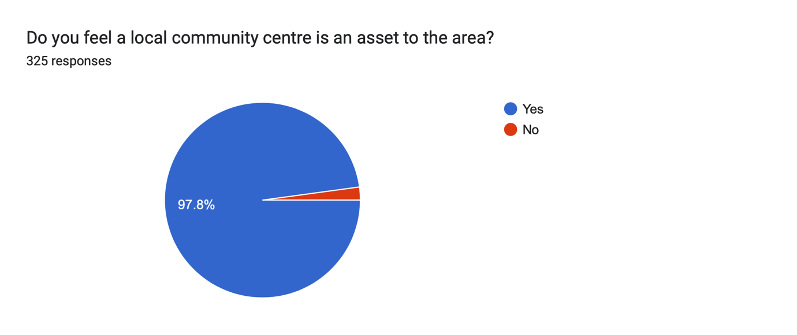
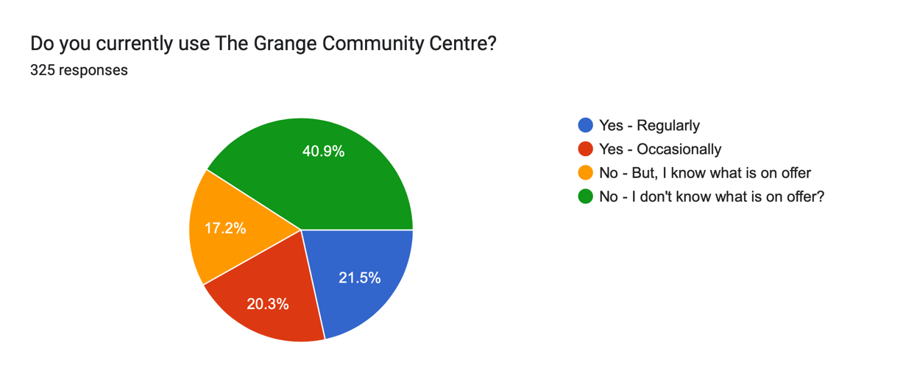
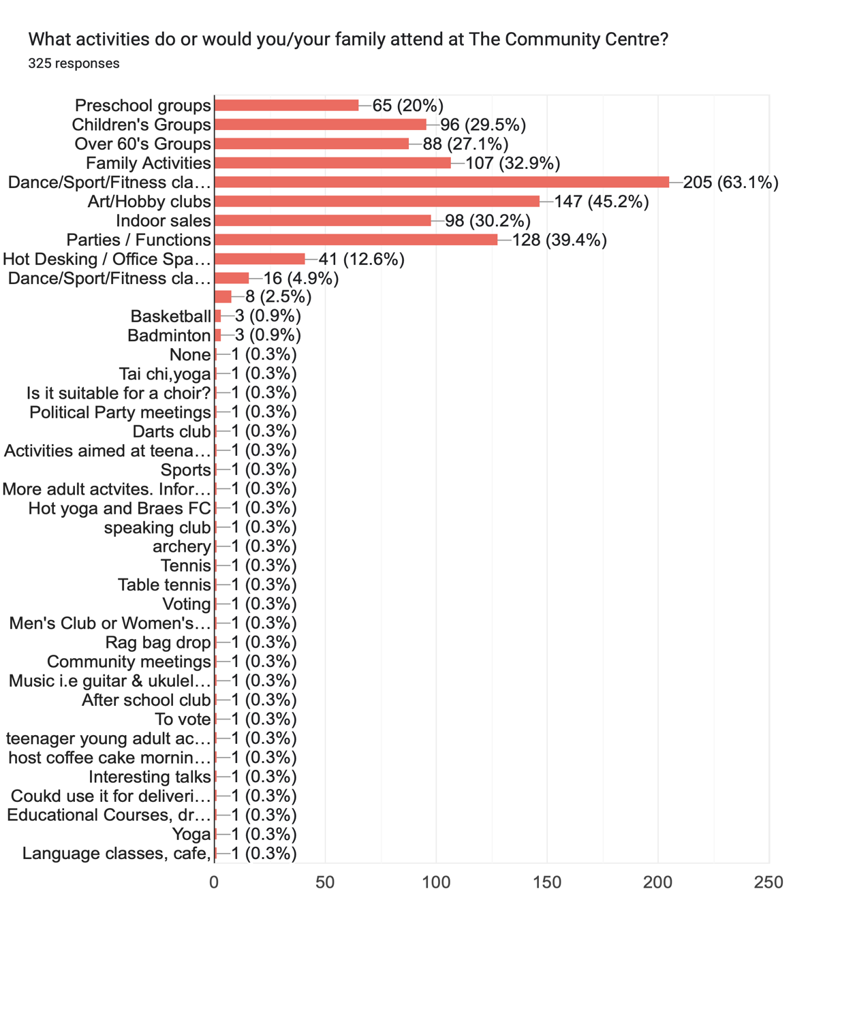
We used the information from the above survey responses, especially “Do you currently use the Grange Centre?” and tackled the issue of not enough people knowing what we offer by designing and promoting the timetable of available activities and subsequent Facebook posts to let the community know how to join in and use the centre. We have already seen an increase in the number of attendees of every club/community group that use the centre.
We also received Letters of Support from all 3 parties and our local councillors. [REDACTED] attended our Open Day and voiced his ongoing support for our endeavours.
Additionally, we have been working closely with Polmont Playgroup to develop their SCIO and CAT application for the Action Outdoors building which shares land with the Grange Centre and in the process we have been discussing the positive ways in which the two charitable organisations can benefit from each other’s existence and work in partnership to promote our services to the community. Polmont Playgroup have 25-35 children and their parents coming to the Playgroup each day therefore will have the opportunity to advertise the activities of the Grange Centre to these parents who otherwise may not have been onsite at the Grange or aware of the offering. Therefore, increasing footfall to the Centre also.
- Funding
  - Please outline how you propose to fund the price or rent you are prepared to pay for the land, and your proposed use of the land.
You should show your calculations of the costs associated with the transfer of the land or building and your future use of it, including any redevelopment, ongoing maintenance and the costs of your activities. All proposed income and investment should be identified, including volunteering and donations. If you intend to apply for grants or loans you should demonstrate that your proposals are eligible for the relevant scheme, according to the guidance available for applicants.
The Falkirk Braes Grange Centre has reserved funds of £35k therefore can afford to absorb the £1 proposed purchase cost. As shown in the below payments and receipts projections, we will rely on grants to help us stabilise the energy costs in the first year and with additional grant funding and support from Business Energy Scotland, we aim to half these costs – especially with the separation of the Action Outdoors building. Additionally, in the below, it only incorporates 3 months of the commercial gym and massage therapist permanent lets, therefore as you can see in the attached 5-year plan, this boosts our income in further years.
Also, we plan to continue to increase the usage of our Sports Hall and other available rooms to bring in additional funds to give us freedom, flexibility and further financial security.
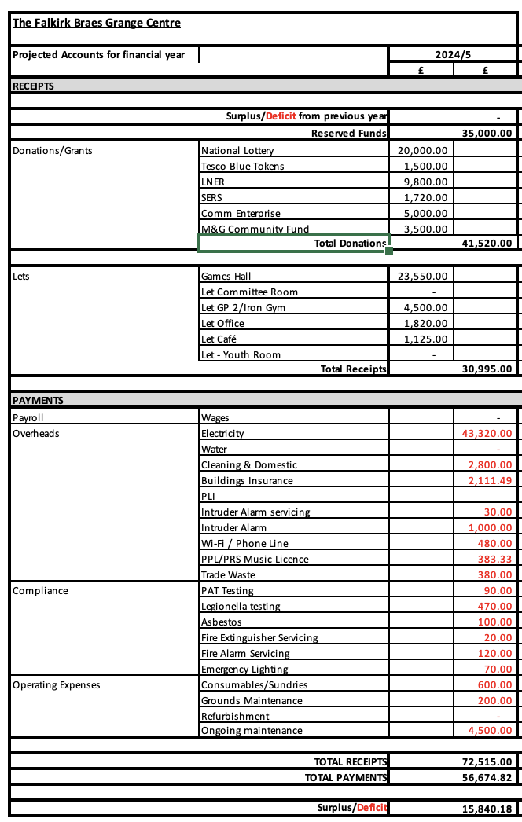
We have 8 trustees each working a minimum of 10 hours per week to support the centre. This expertise equates to £40 per hour, in line with their current employment. Additionally, we have 20 volunteer members, each working a total of 6 hours per month on average. Their expertise equates to £12 per hour. Together this saves a total of 5,600 paid hours per year at a cost of £183,680. Looking at these projections over 5 years, the savings would be:
Year 1 - £183,680
Year 2-3 - £386,845
Year 4-5 - £400,411
(using 3.5% inflationary increase year on year)
As a committee, we will apply for grants on a regular basis to purchase new equipment or refurbish our spaces to being continued improvements.
For the identified repairs, we have £35k reserved in our bank account and we have been applying and identifying additional applicable grants:
- SERS Energy Solutions £1,720 AWARDED
- National Lottery Awards for All - £20k Awaiting decision
- Community Empowerment Grant – CAT Fund £5,760 AWARDED
- Firstport Community Enterprise £5K Awaiting decision
- M&G Community Grant £5k Awaiting decision
- Tesco BlueTokens £1.5k Awaiting decision
- Community Empowerment Grant – Capital Fund £8k Awaiting decision
- Scotmid Community Grants £500 Awaiting decision
- Local Energy Scotland (CARES) Application in progress
Find below proof of our Income and Expenditure over the last 5 years under council management. 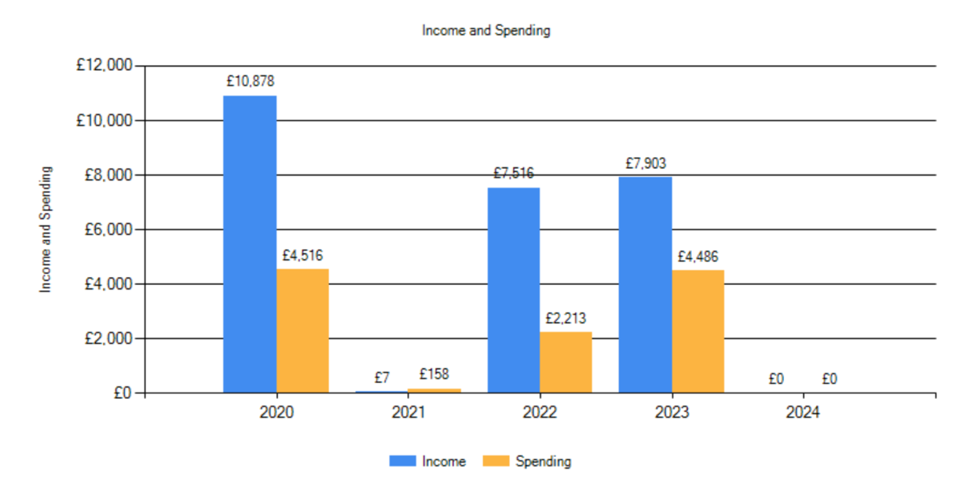
Signature
Two office-bearers (board members, charity trustees or committee members) of the community transfer body must sign the form. They must provide their full names and home addresses for the purposes of prevention and detection of fraud.
This form and supporting documents will be made available online for any interested person to read and comment on. Personal information will be redacted before the form is made available.

We, the undersigned on behalf of the community transfer body as noted at section 1, make an asset transfer request as specified in this form.
We declare that the information provided in this form and any accompanying documents is accurate to the best of our knowledge.
Name [REDACTED]
Address [REDACTED]
Date 9th September 2024
Position Chair
Signature [REDACTED]

Name [REDACTED]
Address [REDACTED]
Date 9th September 2024
Position Secretary
Signature [REDACTED]
Checklist of accompanying documents
To check that nothing is missed, please list any documents which you are submitting to accompany this form.
Section 1 – you must attach your organisation’s constitution, articles of association or registered rules
Title of document attached: The Falkirk Braes Grange SCIO Constitution

Section 2 – any maps, drawings or description of the land requested
Documents attached: n/a pasted into Request document & Business Plan

Section 3 – note of any terms and conditions that are to apply to the request
Documents attached: n/a, within Request document.

Section 4 – about your proposals, their benefits, any restrictions on the land or potential negative consequences, and your organisation’s capacity to deliver.
Documents attached: n/a, within Request document.

Section 5 – evidence of community support
Documents attached: Grange Community Engagement

Section 6 – funding
Documents attached: n/a, within Request document.

